Eyewitness Information Management System
Using Neuro-fuzzy Classification Schemes

Adedeji B. Badiru*, O. Sunday Asaolu, Olufemi A. Omitaomu
Department of Industrial & Information Engineering
University of Tennessee, Knoxville, TN 37996-0700

Abstract
The use of computers in law enforcement has been generally recognized and widely reported in the literature and recent popular press. Law enforcement generates and deals with greater volume of data that takes a lot of time to collate and work with. Previous successes with the use of software tools in law enforcement have paved the way for new and innovative applications of software techniques to aid crime data management and investigation. The emerging area of homeland security is a particularly fertile area of application for software-based investigative tools. Recent developments in fuzzy systems and artificial neural networks have led to the emergence of hybrid software systems that are effective for a variety of ill-structured problems such as crime investigation. One solution to such problems is based on a combination of expert rules, fuzzy logic reasoning, prediction capabilities of artificial neural networks, and the data handling power of computers. This paper presents the development of robust software capable of utilizing and cross-referencing generic problems of witness accounts, crime scene data, and investigators’ experiential reasoning. The software, named EyeWitness Account (EWA), uses neuro-fuzzy classification schemes for suspect identification based on eyewitness accounts.

Keywords: Neuro-fuzzy; expert system; information management; eyewitness account; information classification

* Corresponding author: 416 East Stadium Hall, Knoxville, TN 37996-0700.
E-mail addresses: abadiru@utk.edu (A.B. Badiru); sasaolu@utk.edu (O.S. Asaolu); omitaomu@utk.edu (O.A. Omitaomu).
1. Introduction
Crime eyewitness accounts generate a greater amount of crime data that takes a lot of time, efforts, and resources to collate and work with. Therefore, there are needs for computer tools that can help classify such data in order to determine the level of detailed investigations required. For example, if a computer tool could classify data that fits the description of a wanted criminal as a most likely suspect for another crime in another location; it would help the investigators to collect additional information about the new crime and to inform other units of possible relocation of the criminal. The mathematical models of such crime data and the investigations are neither deterministic nor stochastic, because the concepts formed in eyewitness minds for identifying, distinguishing, and classifying crimes and crime suspects are based on natural languages. Therefore, the description, classification, judgment, and reasons they produce are fuzzy. In addition, such real world data are full of uncertainties and, the information extracted and the decisions made based on these data are often more vague than random and probabilistic techniques could handle. Uncertainties in crime investigation and prosecution are directly linked to economic and social losses such as prolong investigations, arrest of innocent citizens, and concealment of the actual offender. Therefore, techniques for understanding them and minimizing their consequences are necessary (Kim and Diwekar, 2002). A crime eyewitness has the ability of processing crime information based on several societal, cultural, professional, personal, and constitutional factors. The natural languages are practically saturated with inherent fuzziness so that one can express affluent information with a few words. Therefore, the objective of this research is to classify (manage) crime suspects information based on the eyewitness account using hybrid-learning rules to optimize the fuzzy system parameters, and ascertain matching individual profiles. Investigator’s fuzzy reasoning is used to develop expert rules for the aggregation of the eyewitness input parameters. Adaptive Neural Network is used to train the eyewitness account of the suspect's variables and classify suspects. Therefore, a Neuro-fuzzy expert system is a synergistic combination of the transparency of fuzzy expert systems and the learning capability of the neural networks (Pal and Mira, 1999).

2. Literature Review
One challenge to law enforcement and intelligence agencies is the difficulty of analyzing large volumes of security related data involving real or suspected criminal and terrorist activities particularly after the September 11th attack on the U.S.A. The need to improve criminal apprehension rates for a safer society motivates researchers for developing faster, more efficient, cheaper and easily deployed investigative tools. New trends in computational techniques and information technology are being utilized to combat crime globally. For example, the Geographical Information Systems (GIS) is an essential tool used in crime data mapping and analysis. This has been successfully used for car theft and kidnapping control among others and is finding application even in developing countries. An expert system is an interactive-computer based decision tool that uses both facts and heuristics to solve difficult decision problems based on knowledge from an expert (Badiru and Cheung, 2002).

Fuzzy Logic (and reasoning) is a scientific methodology for handling uncertainty and imprecision (Zadeh 1965, 1973). Unlike in conventional (crisp) sets, the members of fuzzy sets are permitted varying degrees of membership. An element can belong to different fuzzy sets with varying membership grade in each set. The main advantage of fuzzy sets is that it allows classification and gradation to be expressed in a more natural language; this modeling concept is a useful technique when reasoning in uncertain circumstances or with inexact information which is typical of human situations. Fuzzy models produce the process output for given inputs. They are constructed based on expert knowledge rather than on pure mathematical knowledge; therefore, they are both quantitative and qualitative, but are considered to be more qualitative than quantitative (Sugeno and Yasukawa, 1993). Therefore, a fuzzy expert system is a computer based decision tool that manipulates imprecise inputs based on the knowledge of an expert in that domain.

Artificial Neural Networks (ANN) is software that models the human process of learning and remembering. ANN involves a simulation of the human brain to model and predict the dynamics of an unknown system from sample sets of input-output data without explicitly determining the underlying relationships. A Neural Network, conceptually and programmatically, is a collection of interconnected processing units, called neurons. A neuron receives a number of inputs; each input line has connection strength, known as weight. The weight of a line can be excitatory (positive weight) or inhibitory (negative weight). Furthermore, a neuron is given a constant bias input of unity through the bias weight. A neuron usually performs two operations: summation and output computation. The summation operation generates a weighted linear sum of inputs and the bias; while the output computation is achieved by mapping the weighted linear sum through an activation function. The interconnected neurons of a network can form a single layer or multiple layers. In addition, they could be unidirectional or bi-directional; hence a neural network has been described as a two-stage regression or classification model (Hastie et al., 2001). Therefore, a neural network system has a good pattern recognition capability but is a black box system because it cannot explain, nor can we tractably decipher how it reaches its decisions.

Researchers have been applying neural-networks to crime investigation. Real world problems are being addressed such as criminal profiling (Strano, 2004), fingerprint identification, speaker identification, handwriting analysis and autonomous face recognition (Rogers et al, 1999). Usually, criminal case information are stored in report files and structured relational databases (in which data are represented as tables consisting of various fields, such crime location, event date, and suspect attributes). Crime investigators can search for useful information in such databases by providing specific search queries (Chen et al., 2002). However, exhaustive queries can not be made to determine hidden entities and linkages within stored data especially in reports. Extracting such entities, a process usually referred to as named-entity extraction, is an application of data mining in crime pattern recognition and criminal relationship identification (Hauck et al., 2002).

A recent computational hybrid is the Neuro-fuzzy system which combines the processing and predictive power of ANN with the broad reasoning capacity of rule based fuzzy models. We believe that law enforcement is a fertile (but hitherto neglected) domain for its application. A specific area of interest is eyewitness accounts. While there is need to bring criminals to justice, care must be taken to prevent the indictment or conviction of a wrong or innocent person (Buckhout 1974, Foxhall 2000). In the literature, eyewitness accounts have been hailed and assailed over the years (Lipton 1977, Loftus and Ketcham, 1991). Badiru et al. (1988) had developed an expert system for processing eyewitness accounts of armed robbery cases (AREST) for the Comanche County Sheriff Department in Lawton, Oklahoma in the mid-1980s. This work presents an extension and an expansion of that work using Neuro-fuzzy techniques.

3. Basic Methodology
Our Eyewitness Account model framework combines a fuzzy expert system and neural networks for effective classification of eyewitness crime information. It compliments the good pattern recognition capability of the neural network system with the good inference mechanism under uncertainty of a fuzzy expert system to offer exciting advantages. Such hybrid model can be used for function approximation and data classification. Therefore, the EWA model is a classifier of suspect databases based on eyewitness account of crimes. In this model, we use fuzzy expert system to classify eyewitness account information based on Mamdani fuzzy model (Mamdani and Assilian, 1975). The resulting EWA software was developed as a pre-processing tool for crime investigators. The expert systems component is based on the knowledge of the experts about the process involved. In this case, the expert knowledge will come from diverse experience of the crime investigators. Such expertise will complement the analytical capability of the neuro-fuzzy methodology. Therefore, the software accepts standard suspect features as input and gives useful classification output using generalized modus ponens inference procedure. Thereafter, known individual profiles are analyzed for matches with the available suspects using neural network training for recognition.

3.1 Software Description
EWA is a Neuro-fuzzy expert system developed from the collaboration of Law Enforcement Innovation Center (LEIC) and IE-Center for Industrial Development Research (IE-CIDeR). EWA aids the law enforcement and security agents (as well as private investigators and the hobbyist Sherlock Holmes) to arrive at some decisions necessary for crime suspect identification and classification. The program is designed to be intuitive and User-friendly. It is an MDI (multiple-document-interface) Windows® application, meaning that one can work with several documents (Cases) simultaneously. It is as simple to use as a word processor. Context-sensitive Help can be obtained at any stage by pressing the F1 key on the computer keyboard. EWA is designed as a pre-processing tool for crime investigators, to help indicate which witnesses and suspects should be accorded primary focus. The product analyzes eyewitness information about crime suspects. Based on configurable criteria, it ascertains a relative degree of the Credibility of eyewitnesses and the usefulness of the information that they have provided. This Credibility can be estimated or quantified based on the suitability and reliability of a Witness. It was based on twenty five fuzzy IF-Then rules developed on the following underlying factors;

Table 1: Factors affecting eyewitness Credibility
 | Factors
1. | distance from crime scene: near, center
2. | Relative perception duration or awareness period at crime scene to total time of criminal event: partial, total
3. | Witness’ physical and mental health (or state of electro-mechanical device) at crime scene: bad, good
4. | ease of testimony extraction from witness: involuntary, voluntary
5. | trustworthiness based on historical antecedents of identified witness or neutrality level (bias) in current case: low, high
6. | consistency of witness information during interview or review: low, high

Crime suspect features (collectively termed Traits) are known with some measure of uncertainty. The Witness specifies a trait value with a corresponding level of confidence (how sure he/she is). Let each (admissible) Witness provide Suspect Description with the vector X = (Sex, Age, Height, Race, Tatoo_Or_BodyMarks, Build_Or_Weight).
The model universe of discourse is shown in Table 2 below.

Table 2: Suspect Attributes
Input Variable  (Suspect Trait) | Parameter 1 (Value ≡ -1) | Parameter 2 (Value ≡ 0) | Parameter 3 (Value ≡ 1)
Sex | Female | Unsure | Male
Age | ≤ 30 years | Unsure | > 30 years
Height | ≤ 5’ 10” | Unsure | > 5’ 10”
Race | Black | Unsure | White
Tattoo_Or_BodyMarks | Absent | Unsure | Present
Build_Or_Weight | Not Heavy | Unsure | Heavy

The previous table ensures that the attainable values are mutually exclusive but altogether exclusive for a given variable. This provision is reasonable and desirable for a simple and intuitive model. Associated with each variable is a Confidence Level C_{oi}, this relates how sure the Witness is in stating that description or the degree of confidence in the information being provided, where C_{oi} ∈ [0.5, 0.75, 1.0]. We eventually construct a more meaningful Confidence Level as a T-norm (e.g. minimum) of Witness Credibility and Variable Confidence Level, that is for each of Sex, Age, and other, we have;
New_C_{oi} = Min (Cr, C_{oi}).

The Described Suspects for any given Case are classified into one of three categories. It is affected by Witness Credibility, Suspect Traits as well as the combinatory characteristics of the Suspect features.

Table 3: Described Suspect Classification
 | Name | Description
1. | Unlikely Suspect | this is due to inadequate or not very reliable information from a Witness, it is for Described Suspects whose "suspectability" rating lie within 0 and 27.5%
2. | Probable Suspect | this is due to better information from Witness, it is for Described Suspects whose "suspectability" rating exceed 27.5% but does not exceed 72.5%
3. | Most Likely Suspect | this is due to very good information from a Witness, it is for Described Suspects whose "suspectability" rating exceed 72.5% but does not exceed 100%
(Note that the given class ranges are not arbitrary but are a mathematical fall-out of the particular "Triangular Fuzzy Membership Function" assumed in our modeling)
After the Classification, Matching of Potential Suspects (real Suspects from law enforcers’ perspective) to the Described Suspects follows. This is to establish how well someone fits a wanted criminal's description. Critical values are highlighted in the resulting table. The interpretation of results is left to the software User or investigator. The same Potential Suspects can be tested against several Cases, each Case file may be saved and the generated Reports edited and exported.

3.2 Expanded Neural-Network Methodology

As an expanded methodology, the Eyewitness Account (EWA) software can be modeled as shown in Figure 1. What goes into the "black box" is a Hybrid NeuroFuzzy Expert System. In this model, we will consider five suspect traits adapted from Badiru et al. (1988) as input variables and three output variables (most likely suspect, probable suspect, and inconclusive
eyewitness account of the suspect). Therefore, the objective of this approach is to classify crime suspects based on the eyewitness account using hybrid-learning rules to optimize the fuzzy system parameters.
Figure 1: A Model for Eyewitness Account for Crime Data Management

Each of the five inputs is limited to three premise parameters (Membership Functions - MFs). The parameters are shown in Table 4. Therefore, with three MFs, there will be 243 (3⁵) fuzzy if-then rules for five inputs as against 6561 (3⁸) fuzzy if-then rules for eight inputs.

Table 4: Suspect Variables and Parameters

Input Variables  (Suspect Traits) | Parameter - 1 | Parameter - 2 | Parameter - 3
Sex | Female | Unsure | Male
Race | Black | Unsure | White
Height | Below 5' 10" | Unsure | Above 5' 10"
Tattoos/Body Marks | Absent | Unsure | Present
Age | Below 30 yrs. | Unsure | Above 30 yrs.
Build/Weight | Not Heavy | Unsure | Heavy

The architecture for the model can be represented as shown in Figure 2.

Figure 2: The Architecture for the Eyewitness Account Model

This architecture has five layers:
Layer 1: This layer generates the membership grades -.
Layer 2: We generate the firing strength based on the eyewitness confidence level -
Layer 3: All firing strengths are normalized -
Layer 4: Calculates rule outputs based on the consequent parameters -
Layer 5: Sum all the inputs from layer 4 -
where x represent the suspect variables as outlined in Table 4 above and y represents suspect classification.

3.3 Universe of Discourse
The universe of discourse will be determined based on EWA description of the suspect's traits and the eyewitness's level of confidence in the information being provided. Trapezoidal membership function is used for the inputs and the outputs.

For examples, let X = EWA of the suspect's sex trait. The possible universal set for the suspect's sex trait is given in Table 5. This is extended to other four suspect's traits.

Table 5: Universal Set for Suspect's Sex Trait
X | Eyewitness Confidence Level about X | Universe of Discourse
Female | 100% - Female | -1.0
Female | 75% - Female | -0.6
Female | 50% - Female | -0.5
Female | 25% - Female | -0.4
Unknown | 100% - Not Sure | 0.0
Male | 25% - Male | 0.4
Male | 50% - Male | 0.5
Male | 75% - Male | 0.6
Male | 100% - Male | 1.0

The MF plot for the sex trait is shown in Figure 3.
Figure 3: Suspect Sex Trait MF

3.4 EWA Scale for Suspect Facial Expression
The facial expression of the suspect is based on a numeric facial intensity scale called Eyewitness Account (EWA) Scale for suspect facial expression. The EWA Scale is a modification of the Wong-Baker Smiley Faces (Wong and Baker, 1988). The suspect facial expression can be described as follows:

Linguistic Description EWA Scale Equivalent
Comforting - 0.0
Friendly - 2.5
Neutral - 5.0
Unfriendly - 7.5
Threatening - 10.0

4. Illustrative Example of the Software Implementation
A hypothetical armed robbery case is analyzed with EWA. The two available eyewitnesses were interviewed and their responses/conducts noted. The first witness described a Suspect while the second witness described two crime suspects. The investigator had three actual (potential) Suspects based on their criminal records and proximity to the crime location. Below are self-explanatory screenshots of some of the input and output screens of EWA for this case.

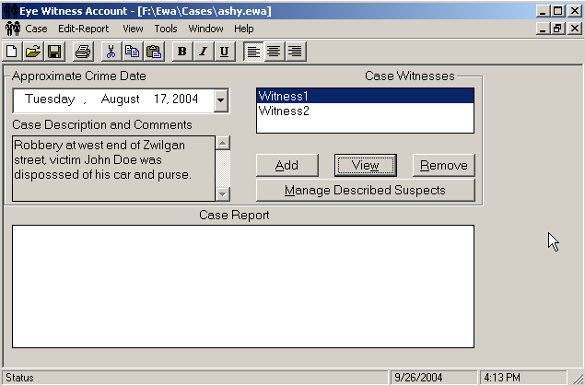
Figure 4: The Case Window of the EWA software

It can be observed that the program features (menus, icons, windows, and buttons) are simple and intuitive. The User can quickly set up and dispense with a Case. For the sample shown, a dated robbery event is treated with two Witnesses to the Crime.
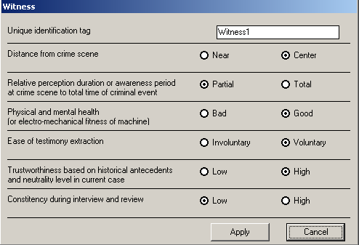
Figure 5: The Witness Attributes Screen of the EWA software

The above screen shows the Investigator’s perception of the first Witness after interviewing the person and cross-checking on the Witness’s background. The section like others, can be revised whenever necessary, for instance in light of new evidence or information. The input from this section is used in the system estimation of the Witness Credibility. Again, it must be emphasized that the relative values and ordering is more important for the section output.

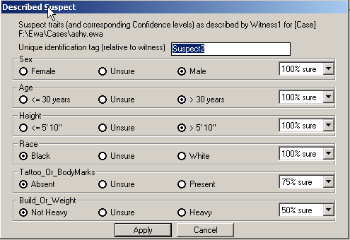
Figure 6: The Described Suspect Attributes Window of the EWA software

The above screen shows the User selection of Suspect traits and corresponding Confidence levels. For instance in this specific Case, the second Suspect described by the first Witness is positively identified as a black male. However, the Witness is not sure about his body build. This could be due to the posture perceived (e.g. if this Suspect was the get-away driver at the wheel).

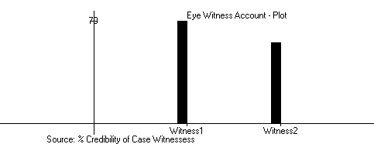
Figure 7: Resulting Plot of Witness Credibility

The above plot generated indicates that the first Witness is apparently slightly more credible than the second Witness in this Case, all factors considered.

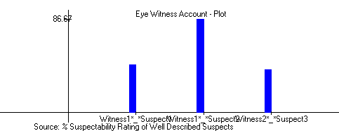
Figure 8: Resulting Plot of “Suspectability”
All Suspects described were found plausible but the Second Suspect (by the first Witness) seems more so. This must be noted by the program User.

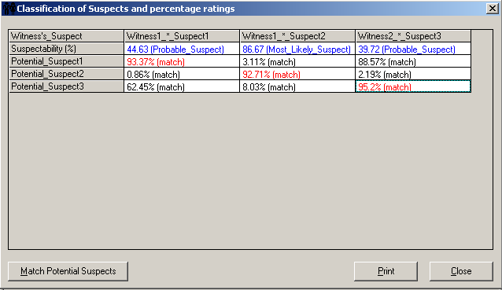
Figure 9: Classification and Match Window

The real people apprehended near the crime scene, those who could have a motive for committing the crime or who are known past offenders are the Potential Suspects. These are considered within the program to see if any does match the eye Witness account. In this Case, matches were found and are thus worthy of further investigation.

From the above screenshots, it could be seen that the first witness is adjudged more credible while the second described suspect is classified as the Most Likely Suspect. That suspect was also closely matched by the second potential suspect.

5. Conclusion
This paper presents a novel application of Neuro-fuzzy computing to develop an expert system for eye witness data analysis in crime investigation. The software demo was presented at the LEIC National Forensic Academy Alumni Retraining Seminar at Knoxville, Tennessee in August 2004. It got very favorable reviews from the vast majority of participants. The general sense is that this is a worthwhile software development effort. The comments of the beta-test audience provided us valuable insights in continuing and enhancing the development of the software. Field tests are currently being run with the finished product (software CD and Users' Manual) and, we intend to continue with the project to release subsequent versions of the software. Example of application areas include pruning a large pool of Witnesses and their Suspect data to prioritize investigative areas, determination of suspect matches by law enforcement officers such as via a laptop simulation in a patrol car, and so on. With the availability of resources, future versions of EWA are expected to be more sophisticated and configurable for web implementation such that the software can be linked to national law enforcement databases. Such web-based versions would be an invaluable tool for security experts in solving and curbing volume of crime cases. It is emphasized that EWA is designed as a time-saving pre-processing tool for investigators and to enhance the management of the volume of crime data being generated daily. It is not expected to provide a final and conclusive identification of a suspect. The human investigator’s experience will still be needed in arriving at a final investigation report. EWA can aid an investigator in quickly sorting through volumes of data available on a particular investigation, thereby increasing the level of confidence associated with the investigator’s conclusions.

References
- Badiru, Adedeji B., Janice Karasz, and Bob Holloway (1988), "AREST: Armed Robbery Eidetic Suspect Typing Expert System," Journal of Police Science and Administration, Vol. 16, No. 3, September, pp. 210-216.
- Badiru, A. B. and J.Y.Cheung (2002), “Fuzzy Engineering Expert Systems with Neural Network Application”. John Wiley & Sons Inc. New York.
- Buckhout, R (1974), “Eyewitness testimony,” Scientific American, Vol. 231, pp 23-31.
- Chen, H.; J. Schroeder, R. V. Hauck, L. Ridgeway, H. Atabakhsh, H. Gupta, C. Boarman, K. Rasmussen, and A. W. Clements (2002). COPLINK Connect: Information and knowledge management for law enforcement, Decision Support Systems, Special Issue on Digital Government.
- Foxhall, K (2000), “Suddenly, a big impact on criminal justice”, Monitor on Psychology Vol. 31, No. 1
- Hastie, Trevor, Robert Tibshirani, and Jerome Friedman (2001), “The Elements of Statistical Learning: Data Mining, Inference, and Prediction.” New York: Springer.
- Hauck, R. V.; H. Atabakhsh, P. Ongvasith, H. Gupta, and H. Chen (2002). Using Coplink to analyze criminal justice data, IEEE Computer, Vol. 35 No. 3, pp. 30-37.
- Jang, J.-S. R., C.-T. Sun, and E. Mizutani (1997), "Neuro-Fuzzy and Soft Computing – A Computational Approach to Learning and Machine Intelligence," Prentice-Hall, New Jersey.
- Kim, Ki-Joo and Urmila M. Diwekar (2002), “Hammersley Stochastic Annealing: Efficiency Improvement for Combinatorial Optimization under Uncertainty.” IIE Transactions, Vol. 34, pp 761-777.
- Lipton, J.P (1977), “On the psychology of eyewitness testimony,” Journal of Applied Psychology, Vol. 62, pp 90-95.
- Loftus E.F and Ketcham K, (1991), Witness for the defense, the accused, the eyewitness and the expert who puts memory on trial. St. Martins Press, New York.
- Mamdani, E.H. & S. Assilian (1975). “An experiment in linguistic synthesis with a fuzzy logic controller.” International Journal of Man-Machine Studies, Vol. 7, No 1, pp 1-13.
- Strano, Marco (2004), “A Neural Network Applied to Criminal Psychological Profiling: An Italian Initiative” International Journal of Offender Therapy and Comparative Criminology, Vol. 4 No 48, pp 1-9. Sage Publications.
- Pal, Sankar K. and Sushmita Mitra (1999), “Neuro-Fuzzy Pattern Recognition: Methods in Soft Computing.” New York: John Wiley & Sons.
- Rogers S.K, Kabrisky M, Ruck D.W and Oxley M.E, (1994), “Neural Networks for fighting Crime,” in Computational Intelligence Imitating Life, Edited by Zurada J.M, Marks R.J and Robinson C, J. IEEE Press New York.
- Sugeno, M. and S. Yasukawa (1993). A Fuzzy-Logic-Based Approach to Qualitative Modeling. IEEE Transactions on Fuzzy Systems. Vol. 1, No. 1
- Wong, D. and C. Baker (1988) Pain in children: comparison of assessment scales, Pediatric Nursing 14(1): 9-17.
- Zadeh, L. (1965), Fuzzy Sets. Information and Control Vol. 8, pp 338-353.
- Zadeh, L.A. (1973). Outline of a New Approach to the Analysis of Complex Systems and Decision Processes. IEEE Transactions on Systems, Man, and Cybernetics, pp 28-44.

Acknowledgments
We acknowledge the funding and support provided for this project by The Law Enforcement Innovation Center (LEIC), University of Tennessee, USA. So many individuals contributed to the success of this project. We sincerely thank everyone, especially the LEIC Executive Director, Mike Sullivan and our Program Coordinator, Amy M. Welch.

About the Authors
Badiru, A. B.: Professor Badiru is the Head, Industrial & Information Engineering Department at the University of Tennessee and the Director of IE-Center for Industrial Development Research (IE-CIDeR).

Asaolu, O. S.: Dr. Asaolu is a visiting scholar at the University of Tennessee from the Systems Engineering Department at the University of Lagos, Nigeria.

Omitaomu, O. A.: Olufemi Omitaomu is a doctoral candidate in the Department of Industrial & Information Engineering at the University of Tennessee.

